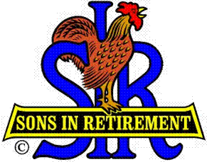

Las Trampas Branch 116

Luncheon Meeting Agenda

September 18, 2017

11:30 AM
- Call to Order – Big Sir.
- Welcome
- Pledge of Allegiance.
- Invocation: Doug Alders
- Introduce Head Table
- Little Sir: Marty Katz
- Guest Speaker – Mark Jordan
- Introduce Guests & Visitors
- Guests:
- Visitors:
- Introduce New Members (if any)
- Big Sir Comment
- Carson City Golf - On to Reno.
- Storyteller – Fred Schafer

11:45 PM – Lunch
- Raffle Drawing
- Sunshine Report – Matt Arena

12:15 PM
- Committee Reports

12:30 PM
Little Sir:
- Introduce Guest Speaker – Mark Jordan – Eclipse and its historical significance.
- Ask September Birthday guys to stand / sing Happy Birthday (Paul King & Robbie)
- Sign God Bless America.

